1, The ramp up function should works with following settings (works only for systems with rectifiers in can1):

**Walk-in time: Long Time**

**Startup delay**

**Generator dependent delay: Enabled**

**Startup delay time: at least 1minutes (could be setup longer)**

**Current rump control: must be disabled**

**Rampup time: e.g. 100seconds (ramping up from 0A to rectifiers max current)**

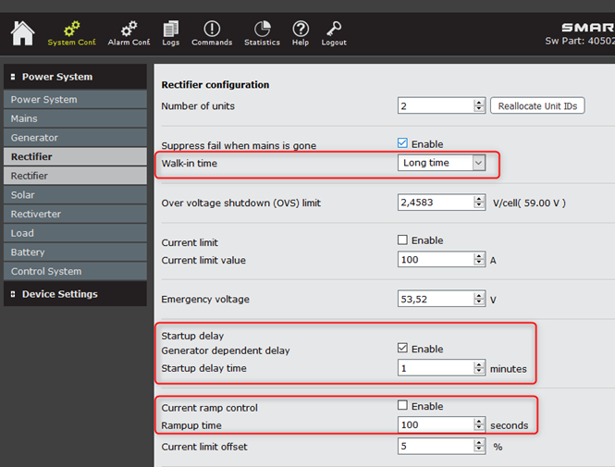

Please check what is the current settings for Mains Configuration

**If  “Suppress mains alarm when generator is stopped“ not Enabled**

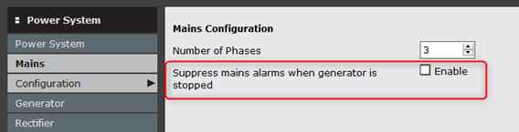

**The “Generator” event have to be adjusted for an input and triggered when Generator start work**(used only if “Suppress mains alarm … “  not enabled)

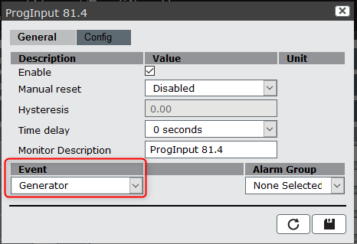

So please test system with settings mentioned above and let me know if rampup function is working now.

2, Generator voltage stop option

Based on answer from our R&D this feature could be implemented in the future, probably for next release of FW. I will come back to you with more details asap.